|  |
| --- |
| Worksheet 5: Using Passive Voice to Report |

|  |  |  |
| --- | --- | --- |
| **Writing in the passive voice**     |  |  | | --- | --- | | **What is passive voice?** | "Voice" refers to the way the verb is used in the sentence.  Remember that a sentence has to have a *subject* and a *verb*, and many verbs require *direct objects*. Here’s an example of *active voice*:  *subject           verb               direct object*              Pete     hit                 the baseball.  *doer             action             receives action*  In *passive voice*, the subject of the sentence also receives the action.  The doer of the action is someone else.  Here’s an example of *passive voice*:  *subject             verb*  The baseball         is hit         by Pete.  *receives action      action        who did the action* |   **Examples of passive voice in lab reports**  ***Correct:***  200mL of distilled water was poured into a 500 mL beaker.  *Incorrect:*  I poured 200mL of distilled water in a beaker. (active voice)  Pour 200mL water in a beaker. (direction/command)    ***Correct:***  The covered crucible was mounted on a ring stand.  *Incorrect:*  We put the crucible on a ring stand. (active voice)  Set the crucible on a ring stand. (direction/command)    ***Correct:***  The temperature was initially measured at 75°C.  *Incorrect:*  I measured the temperature at 75°C. (active voice)  Measure and write down the temperature. (direction/command)  **It's understood that all actions were done by the experimenter.** |

Excerpt from: <https://guides.lib.purdue.edu/c.php?g=352816&p=2377936>

**Exercise A – Find the Passive Voice**

Underline the passive verbs with the preposition that follows each of them in this excerpt from Reading 3 “Dynamic Lighting Systems”.

|  |
| --- |
| *4.1 Method*  The field experiment was designed as a pretest-post-test control group study to investigate the effect of different lighting CCTs when conventional fluorescent lighting was replaced with adjustable solid-state lighting. Two fourth-grade classrooms within the same elementary school in the Republic of Korea were appointed as the control and experimental groups. All students received parental consent prior to the study. In all, a total of 54 responses were analyzed in the study: 27 students from the control group (fifteen boys and twelve girls) and 27 students from the experimental group (fifteen boys and twelve girls). The average age was ten years. All participants had normal or corrected-to-normal visual acuity with no significant color deficiencies.  The experiments were conducted every other day for a period of two weeks. During the pretest (first week), both groups were equipped with conventional fluorescent lighting. However, the lighting in the experimental group's classroom was replaced with adjustable LEDs during the post-test (second week), as shown in Fig. 4. The classrooms were situated side by side on the second floor with the penetration of sunlight from one side. In order to minimize the fluctuation of natural daylight, the experiments were conducted early in the morning. The weather during the experiments was classified as cloudy by the Korea Metrological Administration. The lighting conditions produced in both classrooms were measured on a horizontal plane at the students' desk level, without natural daylight, using a chroma meter, as shown in Fig. 2 and Table 3. The average CCT of the original fluorescent lighting was around 5000 K for both classes. During the post-test, three lighting CCTs were controlled for the experimental room: 3500 K, 5000 K, and 6500 K. |

**Exercise B – Understanding the Passive Sentences**

Copy the sentences that you underlined in the passage into the table to see the pattern more clearly and to examine the purpose of the prepositional phrases, discuss their meaning with classmates.

|  |  |  |  |  |
| --- | --- | --- | --- | --- |
|  | **Subject** | **verb** | **preposition** | **noun phrase** |
| 1 | The field experiment | was designed | as | a pretest-post-test control group study |
| 2 | The lighting | was replaced | during | the post-test (second week) |
| 3 | Two classrooms | were appointed | within | the same elementary school in the Republic of Korea |
| 4 | All students | received | prior to | the study |
| 6 | 54 responses | were analyzed | in | the study |
| 7 | The experiments | were conducted |  | every other day for a period of two weeks |
| 8 | the lighting | was replaced | with | adjustable LEDs during the post-test (second week) |
| 9 | The classrooms | were situated | with | the penetration of sunlight from one side |
| 10 | the experiments | were conducted | In order to | minimize the fluctuation of natural daylight |
| 11 | The weather | was classified | as | cloudy by the Korea Metrological Administration |
| 12 | The lighting conditions | were measured | on | a horizontal plane at the students' desk level, without natural daylight, using a chroma meter |
| 13 | three lighting CCTs | were controlled | for | the experimental room: 3500 K, 5000 K, and 6500 K |

**Exercise C – Turn Instructing to Reporting (MEASURING BRIGHTNESS OF LIGHT)**

Rewrite each of the imperative sentences of instruction into passive voice to report what is done.

1. Turn on the calculator and start the DataMate® program. Press CLEAR to reset the program.

The calculator should be turned on, and the DataMate® program should be started. CLEAR should be pressed to reset the program.

1. Set up the calculator and the interface for the appropriate data collection mode.

The calculator and the interface were set up for the appropriate data collection mode.

1. On the line below your data table labelled *Background,* record the value for the background intensity that appears in the upper-right corner of the calculator screen.

The value for the background intensity that appears in the upper-right corner of the calculator screen should be recorded on the line below your data table labelled Background.

1. Set the bulb and socket 0.10 m from the end of the sensor. Carefully align the sensor clamp and the aperture of the sensor so that the aperture is level.

The bulb and socket should be set 0.10 m from the end of the sensor. The sensor clamp and the aperture of the sensor should be carefully aligned so that the aperture is level.

1. Set the power supply at 4.5 V, and connect it carefully with the wires from the light socket.

The power supply should be set at 4.5 V, and it should be carefully connected to the wires from the light socket.

1. Select START to collect data for the light intensity. Wait five seconds, then press ENTER to collect data for the light intensity.

START should be selected to collect data for the light intensity. After waiting for five seconds, ENTER should be pressed to collect data for the light intensity.

1. Carefully move the bulb to the 0.15 m. Wait five seconds, then press ENTER.

The bulb should be carefully moved to 0.15 m. After waiting for five seconds, ENTER should be pressed.

1. Repeat this procedure for all the distances in your data table.

This procedure should be repeated for all the distances in your data table.

1. After the last trial, press r to stop data collection. Carefully unplug the power supply from the wall outlet.

After the last trial, r should be pressed to stop data collection. The power supply should be carefully unplugged from the wall outlet.

1. Clean up your work area. Put equipment away safely so that it is ready to be used again.

Your work area were cleaned up. The equipment should be put away safely so that it is ready to be used again.

**Exercise D – Coffee Production: How Instant Coffee Is Made**

Look at the pictures and notes below which show how instant coffee is produced.

Write a short description (150 words) of the process using the **passive voice**. You should include 11 verbs in passive voice.

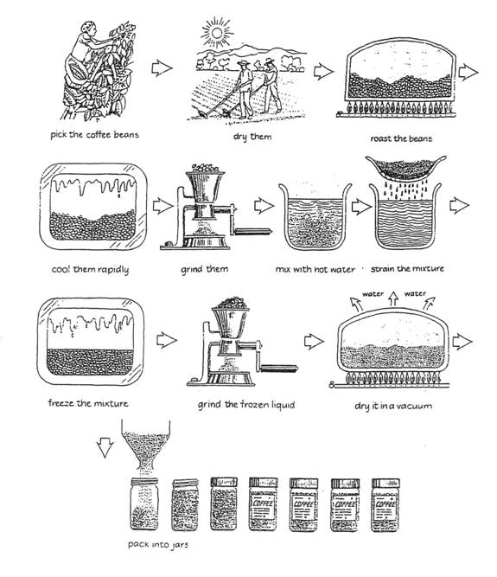

**Your Paragraph:**

The coffee beans are picked, and dried. Then, they are roasted and cooled rapidly. After that, they are ground, and mixed with hot water, and the mixture is strained and frozen. The frozen liquid is ground and dried in a vacuum. Finally, the instant coffee is packed into jars.

(11 past voices with 22 points)